Authentication backend order -> External then Dtabase

External Authentication Type -> LDAP

LDAP URL -> ldap://ip-172-31-24-236.ap-southeast-1.compute.internal:389

LDAP Bind user Distinguished name -> cn=Manager,dc=hadoop,dc=com

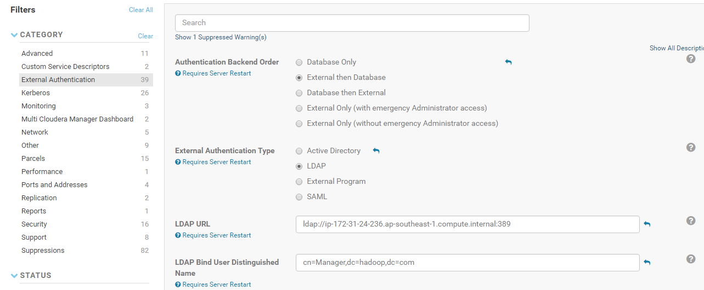

LDAP Bind Password -> Provide bind password

LDAP user Search filter -> (uid={0})

LDAP user search Base -> dc=hadoop,dc=com

LDAP Group Search filter -> objectClass=posixGroup

LDAP Group Search Base -> dc=hadoop,dc=com

User Role Vs Group mappings

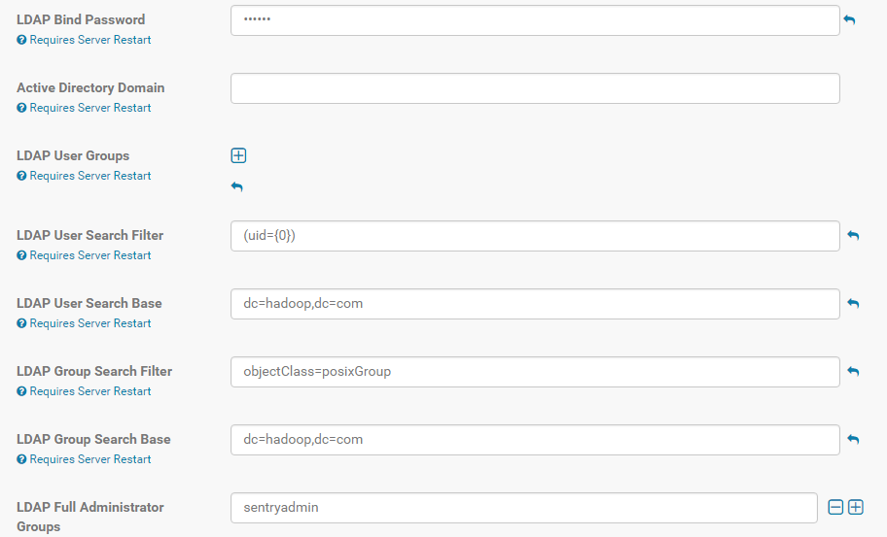

LDAP Distinguished Name Pattern -> uid={0},ou=users,dc=hadoop,dc=com



Create a new organization unit inside LDAP for Cloudera Manager users and groups

Authentication Backend Order -> External then Database

External Authentication Type -> LDAP

LDAP URL -> ldap://ip-172-31-24-236.ap-southeast-1.compute.internal:389

LDAP Bind User Distinguished Name -> cn=Manager,dc=hadoop,dc=com

LDAP Bind Password -> Provide the password

LDAP User Search Filter -> (uid={0})

LDAP User Search Base -> ou=cmusers,dc=hadoop,dc=com

LDAP Group Search Filter -> objectClass=posixGroup

LDAP Group Search Base -> ou=cmusers,dc=hadoop,dc=com

LDAP Distinguished Name Pattern -> uid={0},ou=cmusers,dc=hadoop,dc=com